**RATTHAMNOON PRAKITPONG #63205165**

**[20 marks]**

You are looking to purchase a house to rent out as an investment property.

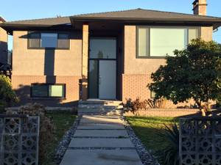

The price of the house is $1,200,000 (consisting of $1,050,000 in land value, and $150,000 in building value). You can finance 75% of this ($900,000) via a bank mortgage at a rate of 3.5% compounded annually (for simplicities sake, calculate all mortgage payments on an annual basis).

You will incur closing costs (land transfer tax, legal fees, etc) of $28,000. Additionally, you would like to spend $75,000 to renovate the house before renting it out. The down payment for the house as well as all the additional fees and renovations will come from your personal savings, which you would otherwise invest in some other manner. Your personal marginal income tax rate is 38%.

**Determine a suitable MARR for this investment [2 of 20].**

*MARR is based on cost of borrowed money, which is mortgage rate set by the bank at 3.5%.*

**Based on this MARR, determine the after tax NPV (using net cashflows), including the effects of inflation.**  Assume you will purchase and amortize the house over 25 years, at which point you will sell it to fund your retirement in the Bahamas. **[12 of 20]**

Other relevant data:

* Building CCA Class 3 (4%)
* Maximum allowable rent increase in BC (this year): 3.7%
* Mortgage term: 5 years
* General Inflation Rate (last five years): 1.8%
* Housing Specific Inflation Rate (last five years): 15% (affects both land value and building value)
* Expected annual rent in year 1: $35,000
* Expected annual expenses in year 1: $17,000 (property tax, maintenance, tenant related expenses)

*Assumptions:*

* *For inflation calculations, real dollar is calculated to year 0.*
* *For simplicity’s sake, I’ll assume that rates are going to be the same for next 25 years.* 
  + *While all the rates are approximately constant every year (inflation ~2%, rent increase ~3%, etc) which makes our assumption work, housing inflation rate stands out as most unpredictable and a tad bit too high at 15%. That said, later on the calculation we’ll see that the rate of return is*
* *Capital gains tax in Canada is 50%, and it’s only realized when property is sold (after 25 years) (https://www.wealthsimple.com/en-ca/learn/capital-gains-tax-canada#sample_calculation_of_tax_on_a_capital_gain).*
* *In the yearly calculation, only annual expenses will be tied to inflation since it’s mortgage is fixed at interest rate and rent increase is mandated.*
* *If there is loss on a year (ie taxable income in negative), I can deduct half of that loss from my other income (https://turbotax.intuit.ca/tips/understanding-business-investment-losses-6104). I will count that tax savings as income (similar to how tax is counted as expense).*
* *Both the land and the building’s value will grow at housing inflation rate.*

*To calculate CCA, we need to know depreciable capital cost. We can easily say that it is $150 000, since that is the cost of the building which is depreciable, while the land can’t be depreciated.*

*For mortgage payment, we can calculate it as a yearly annuity.*

*Yearly mortgage = Principal * (P/A, 3.5%, 25)*

*= $900 000 * 0.06067*

*= $54 606.63*

*For each year, we have:*

*Mortgage interests = Prev year principal * 3.5%*

*Mortgage principal = Mortgage – Mortgage interests*

*UCC at year start = Prev year UCC – Prev year CCA*

*CCA = UCC at year start * CCA rate*

*= UCC at year start * 4% (except for first year where it’s 2%, only half claimed)*

*Rent = Prev year rent * (1 + maximum allowable rent increase)*

*= Prev year rent * 1.037*

*Expenses = Prev year expenses * (1 + inflation)*

*= Prev year expenses * 1.018*

*Marginal rate = 0.38*

*Before tax cash flow = Rent – Expenses – Mortgage principal*

*Tax = Taxable income * Marginal rate*

*= (BTCF – CCA – Mortgage interests) * Marginal rate*

*Income = BTCF – Mortgage interests – Tax*

*Income in real collar = Income * (P/F, 1.8%, n)*

*We can put this into a spreadsheet:*

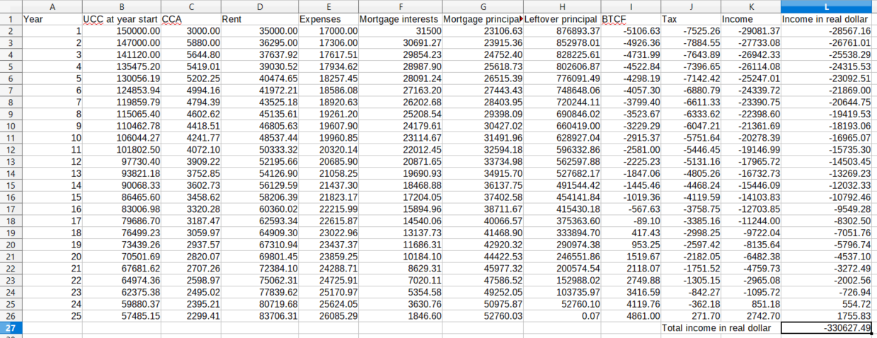*We can see that due to high mortgage and expenses, we run on losses on most years. However, at the end of 25th year, we own the house fully and we can sell it:*

*Property value, year 25 = $1 200 000 * (F/P, 15%, 25)*

*= $1 200 000 * 32.92*

*= $39 502 743.14*

*Recaptured CCA = Cost basis – book value*

*= $150 000 - ($57 485.15 - $2 299.41)*

*= $94 814.26*

*Income tax on RCCA = Recaptured CCA * 38%*

*= $36 029.42*

*Capital gains tax = (Selling price – cost basis) * 50%*

*= ($39 502 743.14 - $1 200 000) * 0.5*

*= $19 151 371.57*

*Sale income = Property value – Income tax on RCCA – Capital gains tax*

*= $19 115 342.15*

*Sale income, real dollar = Sale income * (P/F, 1.8%, 25)*

*= $19 115 342.15 * 0.64*

*= $12 237 356.89*

*Summing total of yearly income, sale income, and capital cost, we can get present value of this investment:*

*PV = Sale income + Total of yearly income + Capital cost*

*= $12 237 356.89 + (-$330 627.49) + (-$403 000)*

*= $11 503 729.40*

**What is your real rate of return on this investment?** **[2 of 20]**

*With $403 000 invested out of pocket, $11 503 729.40 (in real dollar) is earned after 25 years. We can calculate real rate of dollar by calculating for interest rate in the following equation:*

*$11 503 729.40 = $403 000 * (F/P, i, 25)*

*(1+i) = 28.545 ^ (1/25)*

*i = 14.34%*

*However, we can say that the current housing inflation rate at 15% is too optimistic. We can retry the rate of return calculation at 5%, which is down by 2/3 and is much more pessimistic.*

*Property value = $1 200 000 * (F/P, 5%, 25) = $4 063 625.93*

*Sale income, real dollar = (Property value – Recaptured CCA tax – Capital gains tax) * (P/F, 1.8%, 25)*

*= ($4 063 625.93 - $36 029.42 - ($4 063 625.93 - $1 200 000) * 0.5) * 0.64*

*= $1 661 301.47*

*i = (($1 661 301.47 / $403 000)^ (1/25)) – 1 = 5.83%*

*We have shown that even at a pessimistic housing inflation rate, our rate of return at 5.83% is still well over MARR of 3.5%, which means that this is good investment.*

Points to consider – ensure these points are addressed in your calculations

* How should you establish your cost basis for depreciation/CCA? What factors should be included, and what should not?
* Be careful about what point your capital purchases and dispositions are accounted for in your cashflows.
* Do you expect the current rates of general and housing specific inflation to continue for the life of this analysis (25 years)? How did this consideration affect the rates you chose to use in your calculations?
* Remember the ½ year rule for CCA. Assume you purchase the house in year zero and claim the first year’s CCA in year zero. Loan repayments begin in Year 1.
* When you sell, how much will you receive for the land, and how much for the building? How will this affect your CCA recovery and capital gains?
* What inflation rate should you use when determining your real rate of return and why? Would there be circumstances where it would make sense to use a different one?
* Assume tax credits (negative income taxes owed) are received in the year they occur.

**Points to discuss [4 marks]** – you do not need to do additional or multiple analyses for these, but briefly discuss how these items could affect your analysis and what you would to do account for them.

* The allowable increase in rent this year is 3.7%, and is based off of the general inflation rate. Do you expect this rate to continue? While this is the maximum rent increase, will you actually impose that consistently? Conversely, when tenants move out you can adjust the rent free of any constraint. How would that impact your analysis?
* Do you expect to renew your mortgage at the same interest rate? How would you account for this in your analysis?
* What factors is your investment most sensitive to? You do not need to do a full blown sensitivity analysis, but identify which factors have a major impact on your NPV. What risks do they pose and how could you mitigate them?

1. *I think that 3.7% is a reasonable assumption that is consistent with historic allowable increases of between 2~4% (*[*https://www2.gov.bc.ca/gov/content/housing-tenancy/residential-tenancies/during-a-tenancy/rent-increases*](https://www2.gov.bc.ca/gov/content/housing-tenancy/residential-tenancies/during-a-tenancy/rent-increases)*). Personally, it depends on the tenants, a good tenant maintains the property well, and causes less stress for landlord. It may be worth it if not increasing rent can keep them on, so in my analysis, I assumed that I would not be increasing rent. Big rent bump will improve returns in the analysis.*
2. *I don’t expect us to renew mortgage at this interest rate. However, to check if our investment will still be profitable at higher rate, we can use the mortgage stress test rate (~5%) in our calculations. The rate in the stress test is standardized and made to specifically to stress test repayment / investment of property.*
3. *I’d say it is the housing inflation rate, since we’re taking losses on yearly income and selling at the end is how we make that loss up. That said, we’ve done a second calculation at a much lower growth rate and the return is still positive.*

**Bonus Question [1 mark]**: **If you had the ability, would you buy a house in Vancouver today, and why?**

*If I’m Canadian, I would, since primary residence is protected from capital gains tax, and monthly mortgage payment on an older 1br apartment is approximately equal to rent at this historic-low interest rate, and I intend to stay in Vancouver for the next +25 years. That said, foreign buyers tax threw off the entire calculation.*